Session1:
1,Open Instagram or Flipkart in your browser, use the browser DevTools (Network tab) to find any API request made when you refresh the page, and write down the full request URL, HTTP method, and status code.
Request URL
https://1.rome.api.flipkart.com/4/page/fetch?reqhash=1144769623
Request method ; POST
Status code : 200 Ok

2.Using Postman, send a GET request to https://jsonplaceholder.typicode.com/posts and note the status code, response headers, and the first post's title.

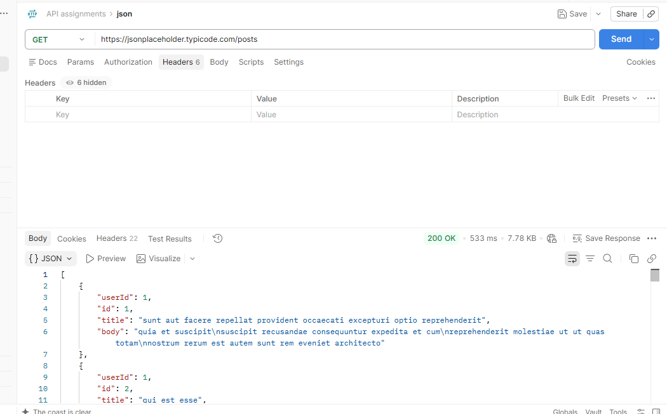

3.Create a simple JSON object representing a Zomato-style restaurant resource with fields like name, cuisine, and rating, then write an example of how you would send this object in the body of a POST request.

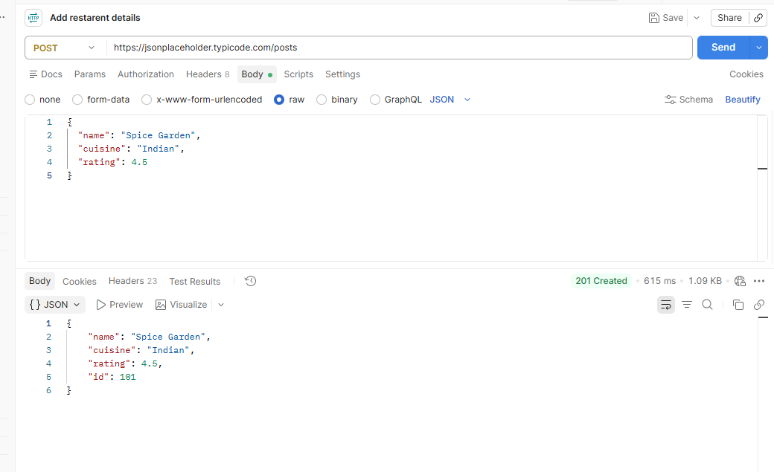

4.List the differences between PUT and PATCH methods by giving a real-world example for each, such as updating your profile info in a food delivery or social media app.

Difference between PUT and PATCH
Feature | PUT | PATCH
Purpose | Replaces the resource | Updates specific fields
Request body | Usually sends the complete resource representation | Sends only the fields to change
Data sent | All required profile fields | Only changed fields
Example | Replace your entire profile | Change only your phone number
Idempotency | Generally idempotent | Depends on the patch operation; often idempotent

5.Pick any API you found in DevTools or Postman and explain what would happen if you sent the same request without the required headers (like Content-Type or Authorization).<br><br><em><strong>Hint:</strong> Try removing a header in Postman and observe the response status code and message.</em>

